**Course Project - SAS Custom Reporting**

Shaun Pritchard

Rasmussen College

QMB4200

Terry Brookhouser

November 5, 2020

**Course Project - SAS Custom Reporting**

Custom SAS scripts using PROC TABULATE and PROC REPORT for QMB4200 Module 5.

**PROC TABULATE Code:**

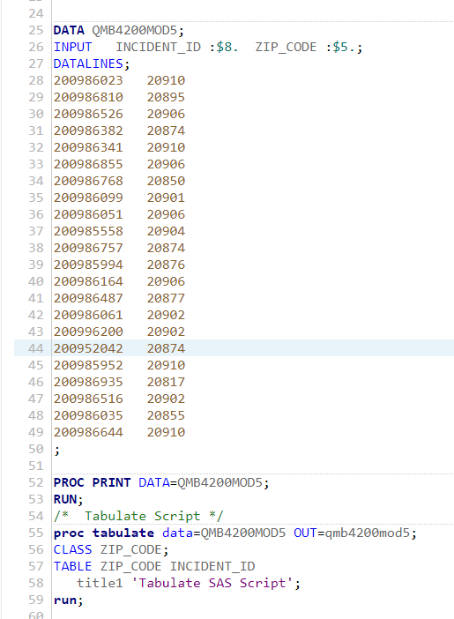

**PROC TABULATE Output:**

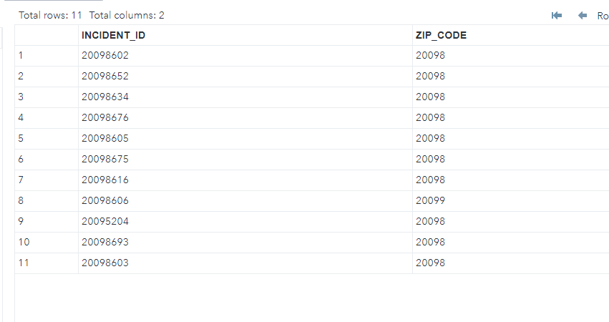

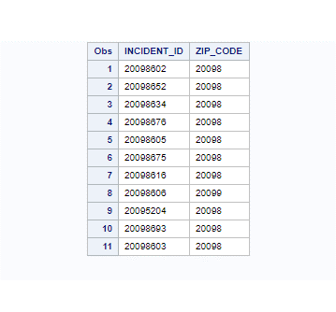

**PROC REPORT Code:**

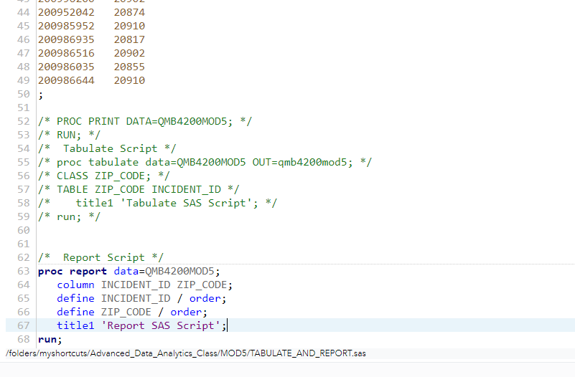

**PROC REPORT Output:**

Here is the report with my original data used in PROC TABULATE



Here is the data report after I duplicated some values.

